NyxGuard Plus Technical Explanation
English translation of the supplied project documentation, covering the module diagram, specifications, and companion app. The listed specifications are source statements, not independently verified test results.

Module block diagram
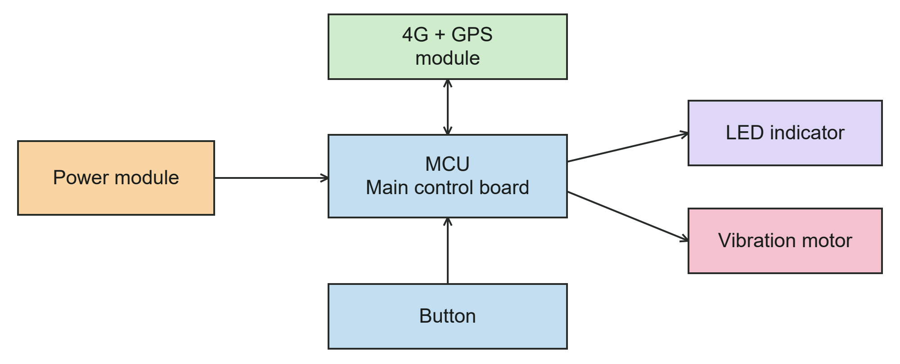
The blocks and connections follow the supplied diagram; labels are translated into English.

Specifications listed in the source
No. | Parameter | Specification
1 | Main microcontroller | STM32F103ZET6
2 | 4G communication module | EC800M
3 | SIM card and network | Multi-carrier SIM card; 4G cellular network.
4 | Positioning modes | GPS and cellular base-station positioning. GPS takes priority; the source specifies automatic switching to base-station positioning when the GPS signal is weak.
5 | Battery capacity | 2000 mAh
6 | Operating time | 14 hours on a full charge, as stated in the source. Test conditions are not provided.
7 | Charging connector | USB Type-C
8 | Communication functions | App connectivity over the 4G cellular network; support for “offline” SMS and voice calls, as worded in the source. See the clarification below.
9 | Vibration motor speed | 9000 rpm
Translation clarification: The source does not define “offline” in item 8. It should not be interpreted as a guarantee of sending messages or making calls without cellular service. Battery-life conditions and positioning-switching test results are not supplied in this document.

Companion app interface
Three main pages provide device status, emergency-contact settings, and SMS and map settings. The supplied screenshots already show the app’s English interface.
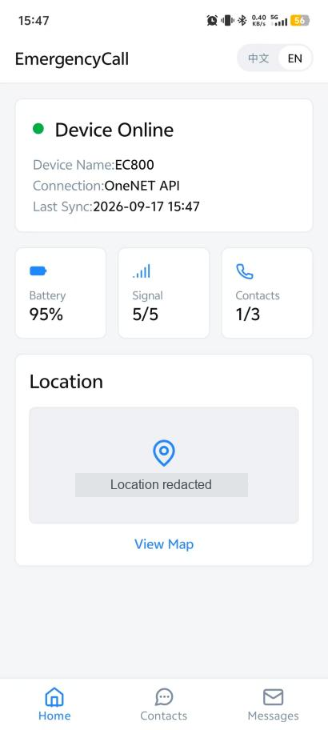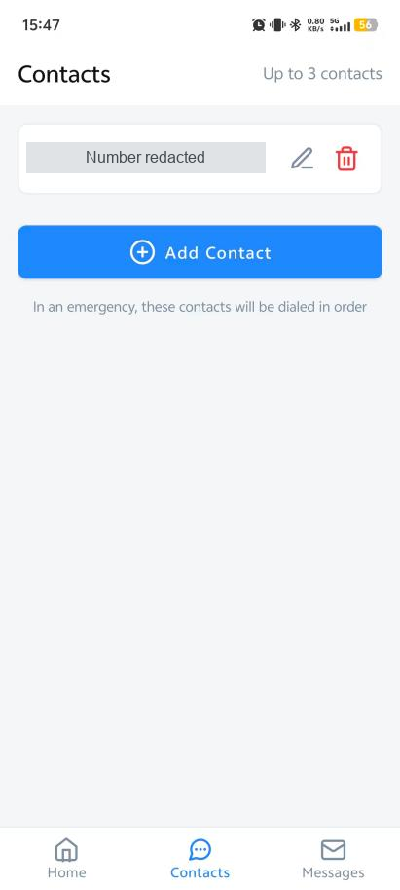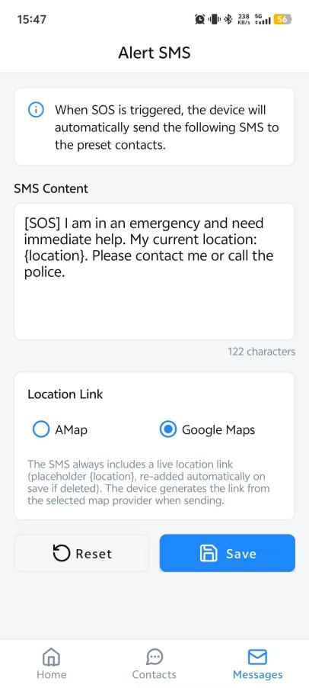
Left to right: Home, Contacts, and Messages. The phone number and coordinate values have been redacted; the remaining interface is retained from the source screenshots.
Home. Shows device connection status, device name, connection service, last synchronization time, battery level, signal strength, contact count, and location information, with a View Map button.
Contacts. Supports up to three preset contacts, with add, edit, and delete controls. The interface states that the contacts will be dialed in order during an emergency.
Messages. Allows the alert text to be edited and the map-link provider to be selected between AMap and Google Maps. The interface includes the {location} placeholder and Reset and Save controls.
These screenshots document the supplied interface. They do not establish that an alert was delivered, a call connected, or every configuration was tested.

Source and contribution
Translated from the supplied Chinese technical explanation. Xiaowei led requirements, design, development and debugging of the Phase II companion app, testing, and iteration. A technical team assisted with circuit assembly, soldering, and parts of the engineering implementation.

